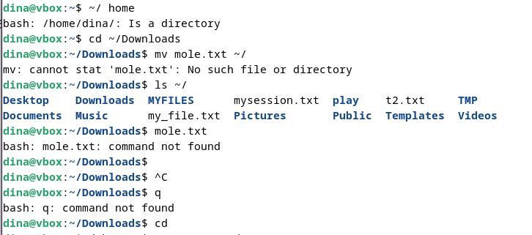Lab 1.3--------🡪 it is not working and I need an additional program. I am trying to install that.